# Assignment -3

Python Programming

|  |  |
| --- | --- |
| Assignment Date | 12 October 2022 |
| Student Name | Sriharan.V |
| Student Roll Number | 19BEC026 |
| Maximum Marks | 2 Marks |

# Question-1:

Write python code for blinking LED and Traffic lights for Raspberry pi.Only python code is enough, no need to execute in raspberry pi.Note: you are allowed to use web search and complete the assignment.

# CODE:

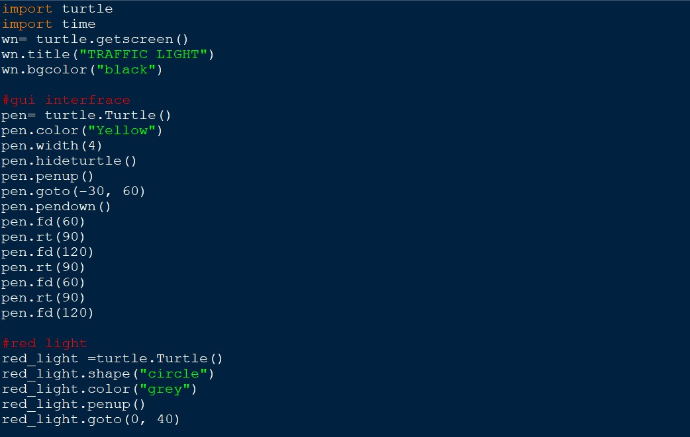

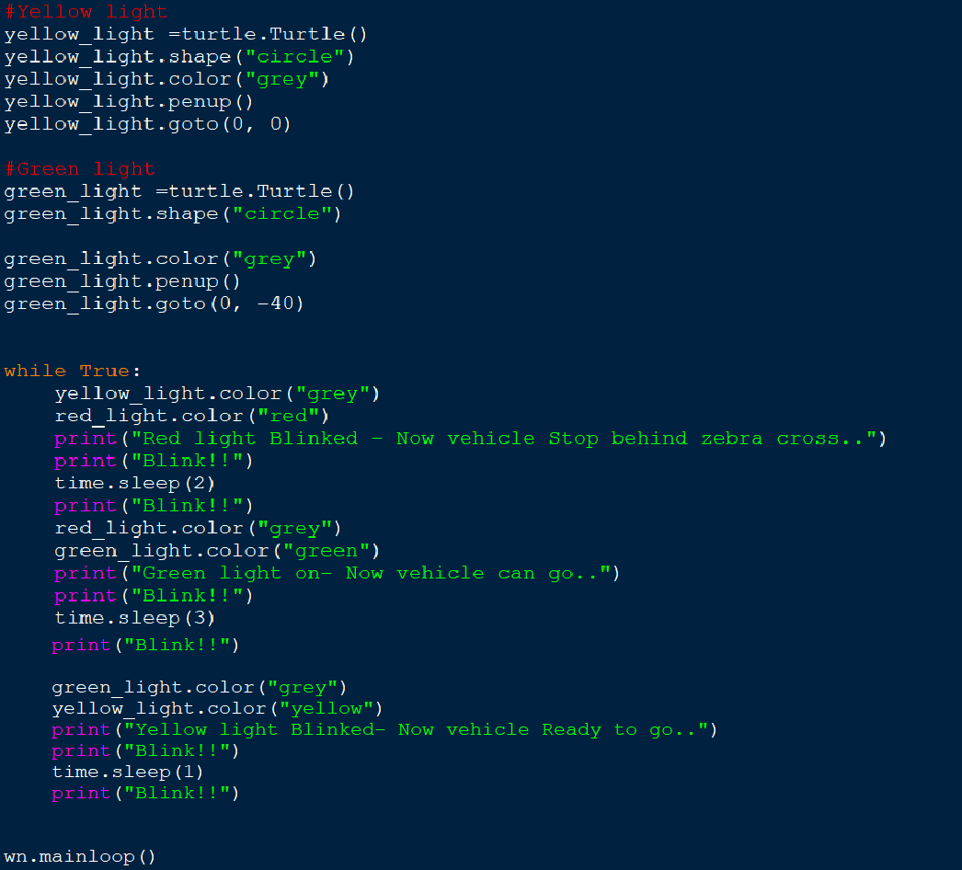

**OUTPUT:**

